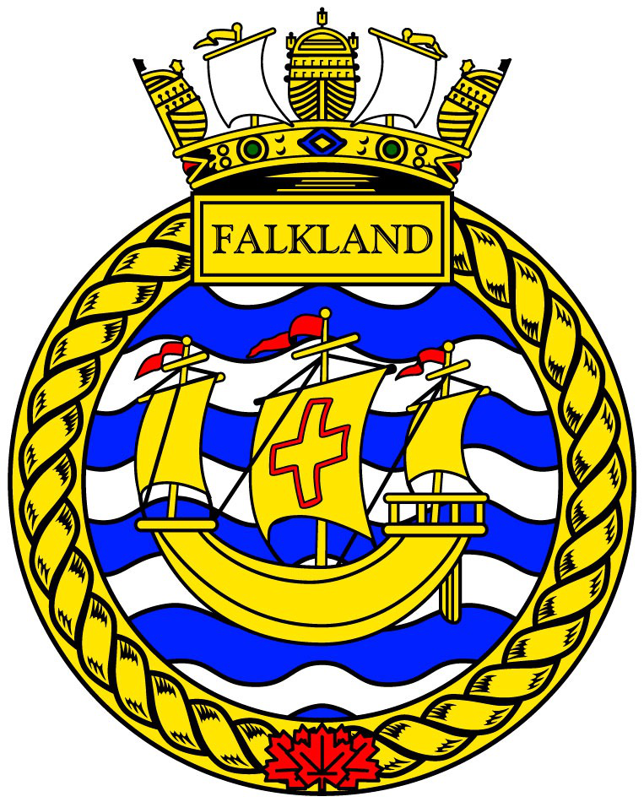
Uniform Request Form
Rank: Click or tap here to enter text. | First and Last Name: Click or tap here to enter text.
Phase: Click or tap here to enter text. | Today’s date: Click or tap here to enter text.
Email address: Click or tap here to enter text.

Uniform pieces requested / Reason for request
Part of uniform (tunic, pants, boots) | Reason for request (too small, too short). Please use as many details as possible (too short on the arms, too tight around the waist) | Current size (see number inside, ex: 6329)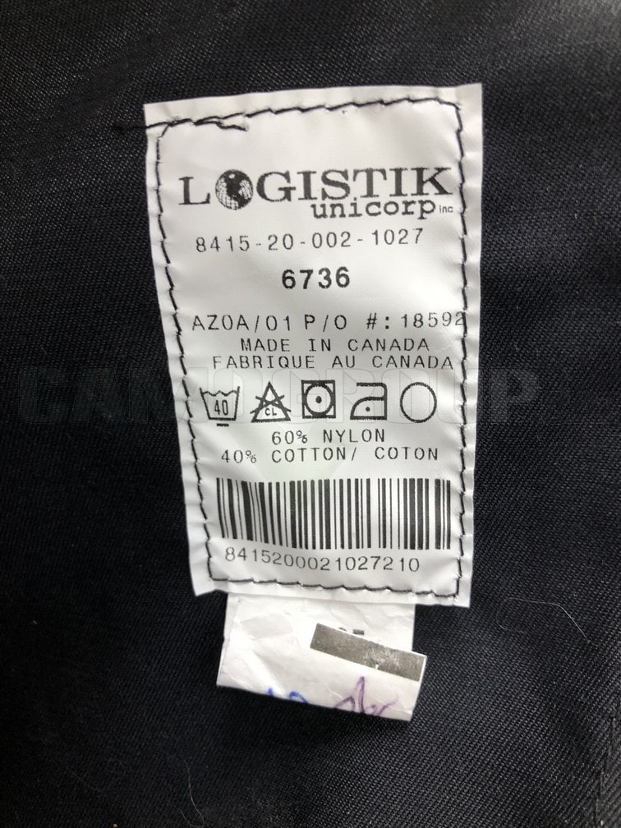
Click or tap here to enter text. | Click or tap here to enter text. | Click or tap here to enter text.
Click or tap here to enter text. | Click or tap here to enter text. | Click or tap here to enter text.
Click or tap here to enter text. | Click or tap here to enter text. | Click or tap here to enter text.
Click or tap here to enter text. | Click or tap here to enter text. | Click or tap here to enter text.
Click or tap here to enter text. | Click or tap here to enter text. | Click or tap here to enter text.
Click or tap here to enter text. | Click or tap here to enter text. | Click or tap here to enter text.

Missing badges and other requests:
Click or tap here to enter text.

Measurements: Please use the measuring instructions found here. Specify unit of measure (inches or cm). You will need a measuring tape.
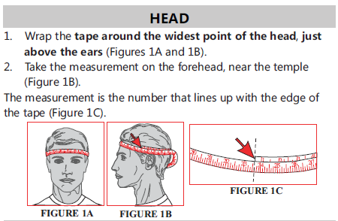
Head: _______________________

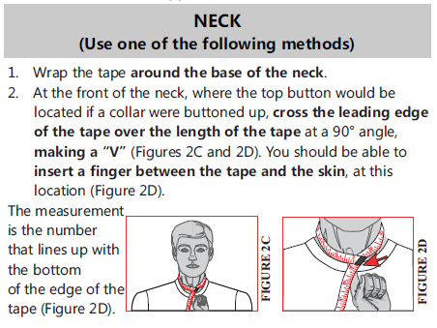
Neck: _______________________

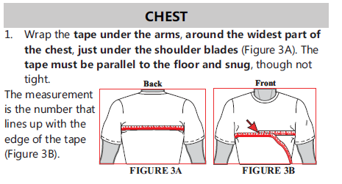
Chest: _______________________

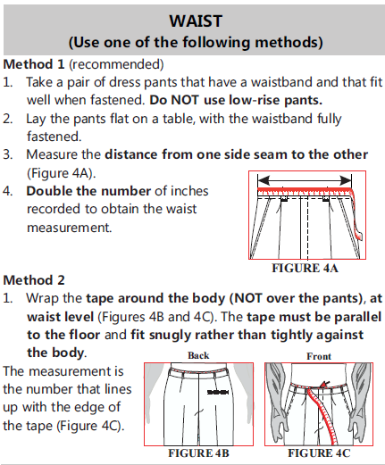
Waist: _______________________

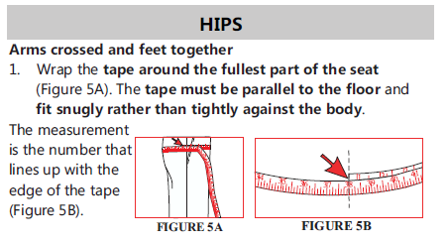

Hips: _______________________

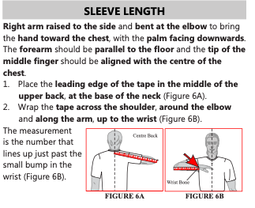

Sleeve length: ______________

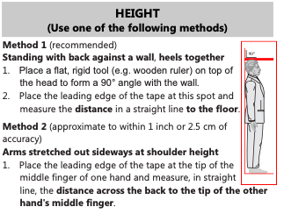

Height: ___________________

Boot/shoe size: Please indicate your current size of “street shoes” or
Current uniform boots (example 260/102) _____________________

-Stand on a ruler and record length and width in mm
Length ____________________
Width _____________________

